Component | Original code | What we changed it to
Outlier detection | z-score only, threshold = 2.0 | Combined z-score (threshold lowered to 1.5) + IQR test
Structural breaks | Not handled at all | New: detects large, persistent one-year declines (>40%) excludes pre-break data from model fitting
Gap handling | Assumed every row is one consecutive year apart | New: growth rates are annualized by actual year gap, not by row index
Backtesting | Single fixed 2-year holdout | Rolling-origin (walk-forward) validation across every viable origin
Scenario forecasts | Percentile growth rate (25th/50th/75th) compounded forever — exploded to unrealistic ranges | Replaced with a plausibility check instead (see below); scenario columns dropped from the multi-company output in favor of a single ensemble + explicit flag
Plausibility check | None — every forecast was presented at face value | New: flags any forecast implying >60%/yr growth or worse than -25%/yr decline as flagged_implausible, with a plain-English reason
Data tiers | None — assumed every company has enough history | New: adaptive tiers (NO_DATA / FLAT / MINIMAL / LIMITED / FULL) based on years available, each handled differently

Annual Forecast:
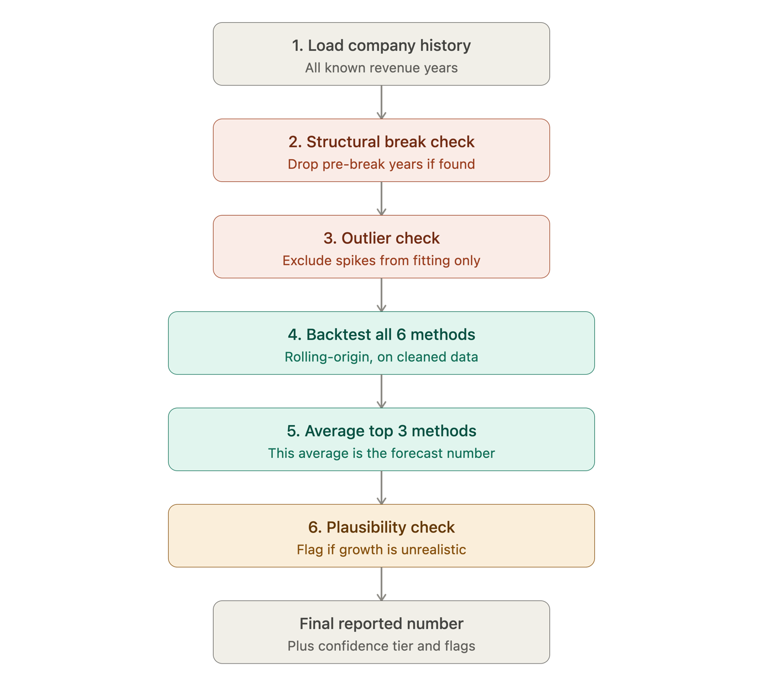

Quarterly Forecast:
